Website text - update

LGBT+ History Month Display and Festival
Join us for our annual celebration of LGBT+ History Month in partnership with Schools OUT UK. The theme for 2026 is Science and Innovation and our foyer display will be running from Friday 13 February to 1 March. The display will feature the life story of Scientist Magnus Hirschfeld. Our LGBT+ History Month Festival event on 21 February 11am– 4pm will include current LGBT+ scientists, recognition for historic LGBT+ pioneer scientists and a creative scientific poetry workshop. All welcome, no booking required.

The image of Magnus Hirschfeld needs the following credited caption:
‘Signed Photograph of scientist Magnus Hirschfeld, 1927© United States Holocaust Memorial Museum’

Image Caption 2
‘Ezra-Quinn Watson speaking at The Higgins, July 2025 ©Lydia McDonald’

Events:
Link to Flyer
LGBT+ History Month Festival
Saturday 21 February 2026
11am-4pm
Barbican Studio, Free Entry no booking required, registration on arrival

11am Registration and Welcome
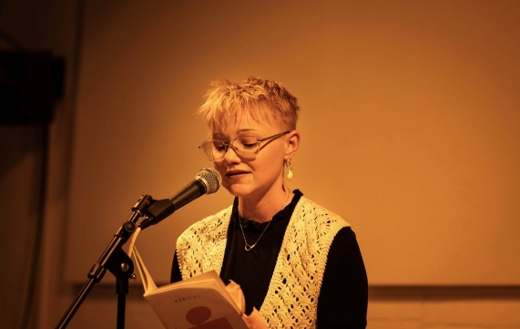
11.05am – 12.20pm Katie O’Pray Science and Innovation themed Poetry Workshop

Science and innovation have historically been both liberators and oppressors to the LGBTQ+ community. One most stark example of this would be the concept of conversion. In this creative workshop, we will draw on the themes of this year's LGBTQ+ History Month, as we read, talk and write together. We will have time to consider a source poem as a group, and respond to a writing prompt independently. If you find you want to read out your piece, you'll be warmly welcomed - but sharing is definitely not a requirement. Age 16+ recommended

12.20-12.30pm comfort break Rainbow Bedfordshire will be encouraging participants to make their own pronoun badges in all our breaks.

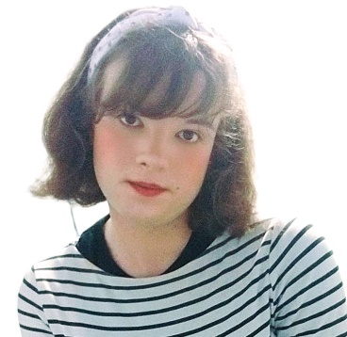
12.30pm-1pm Renna Mitchell ‘Magnus Hirschfeld, LGBT+ Scientist and Pioneer’
Our display focusses on the life of Magnus Hirschfeld, one of the leading pioneer German Jewish scientists from the late 1890s to early 1930s. Renna, a The Higgins Bedford volunteer and member of Rainbow Bedfordshire will be speaking about how Hirschfeld was an exceptional role model and campaigner for LGBT+ Rights at a time when there was a great deal of persecution, restriction and misunderstanding for the community.

1-2pm Lunch and badge-making with Rainbow Bedfordshire

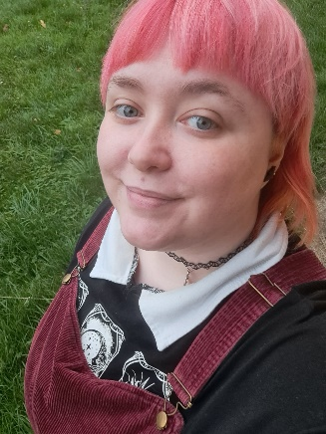
2-2.45pm Ezra-Quinn Watson ‘Recontextualising 19th Century Fiction, discovering queerness’.
Ezra will be sharing their PhD research on connecting historic literature with a 21st Century audience and identity. Exploring classic novels including Jane Eyre, Wuthering Heights and Dorian Gray and themes around concealed identities within the text. Ezra will compare these publications with modern day queer media and adaptations, discussing where we are in understanding queerness within past and present popular culture.

2.45-3pm comfort break and badge-making with Rainbow Bedfordshire

3-3.45pm Max Fisher RSci MRSB (They/Them) - Max is a multi-award winning disability advocate and scientist. They were recognised as the UK's most influential disabled scientist in 2024, and won the Dorothy Jones Award for Diversity and Inclusion in STEM from Applied Microbiology International in 2025. Max has been a practicing pagan since 2009, and a practicing Druid and member of the Order of Bards Ovates and Druids for the past 4 years. They work as a senior research associate at a nanomedicine company based in Cambridge.

3.4-4pm Closing Reflections

